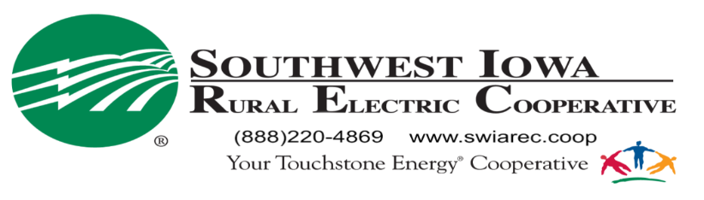
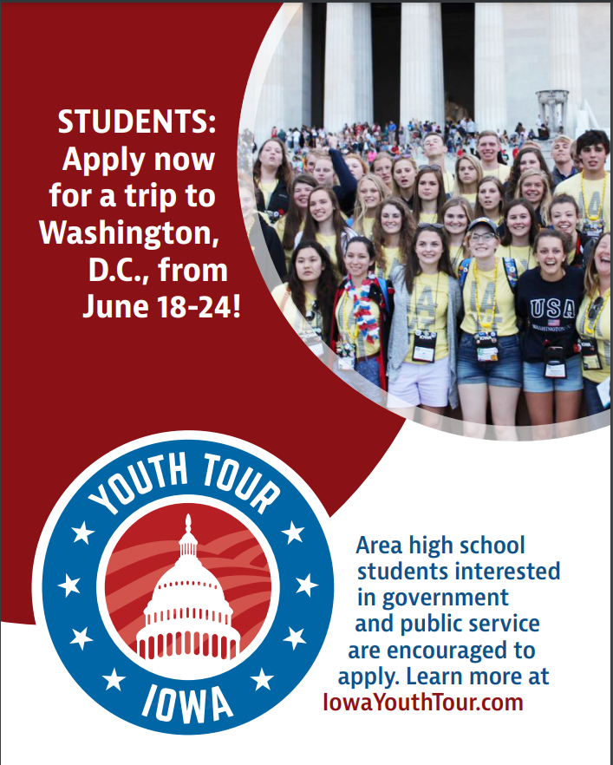

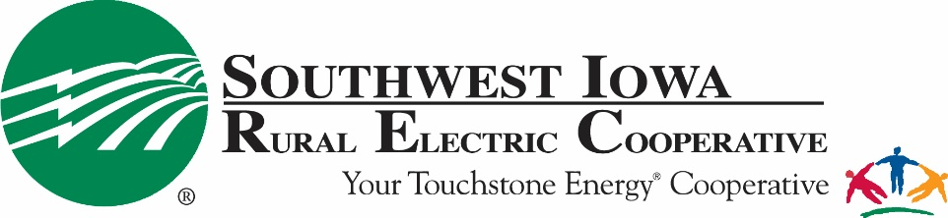

Youth Tour Policy

Objective
Southwest Iowa R.E.C. will send one student to Washington D.C. to participate in the NRECA’s Youth Tour. The program is intended to educate students about Electric Cooperatives, American history, and U.S. government. It also encourages leadership and engagement as a U.S. citizen.

Rules and Procedures
- Applicants must be high school sophomores, juniors, or seniors attending a school within the Southwest Iowa R.E.C. service area.
- Southwest Iowa R.E.C. will choose three applicants based on their answers provided to questions on the application. Those three applicants will be asked to submit an essay and/or quiz and complete an interview. One of these three applicants will be chosen as the winner.
- The three applicants that submit an essay/quiz and complete an interview will be judged by persons from outside Southwest Iowa R.E.C.
- The parents/guardians and student must agree to allow promotional photos and news stories to be developed and published as a Southwest Iowa R.E.C. Youth Tour Winner.
- The winning student must commit to give a 7-to-10-minute presentation at SWIAREC’s annual meeting that follows the Youth Tour they attend.

2022 Washington D.C. Youth Tour
June 18-24, 2022

Name:______________________________________Date:_________________
Parent/Guardian: __________________________________________________
Address:__________________________City,State,Zip_____________________
Phone No:____________________ Email:______________________________
High School:_________________________________ Grade: ______________
Member Account No:________________ Cell Phone No:__________________
Parent/Guardian Cell Phone No: ______________________________________
List of school activities:______________________________________________
_________________________________________________________________
_________________________________________________________________
List organizations and offices held: ____________________________________
_________________________________________________________________
_________________________________________________________________

Attach a one-page essay stating why you would like to win this trip.
*** Please do not include any personally identifiable information as these essays will be blind judged.
1

As an applicant, I understand and agree to follow the rules and procedures stated in the Southwest Iowa R.E.C. Youth Tour Policy.

Signature of Applicant:______________________________________________

As the parent(s) or legal guardian of the above applicant, I/we give our permission for him/her to participate in the Youth Tour contest being conducted by Southwest Iowa R.E.C. The winner of the contest will travel to Washington D.C. I/we agree that his/her entry will become the property of Southwest Iowa R.E.C., and will allow promotional photos and news stories to be developed and published as a Southwest Iowa R.E.C. Youth Tour Winner.

Signature:_________________________________________________________

Signature:_________________________________________________________

Please return completed application and essay by March 15, 2022 to:

Southwest Iowa REC
ATTN: Tim Pfeiffer
415 Broad Ave
Stanton, IA 51573

2

